Devin Hardy

00076619

[Dhardy2@my.athens.edu](mailto:Dhardy2@my.athens.edu)

Asg1

Images seem to be really large, so they are on the next pages. Sorry.

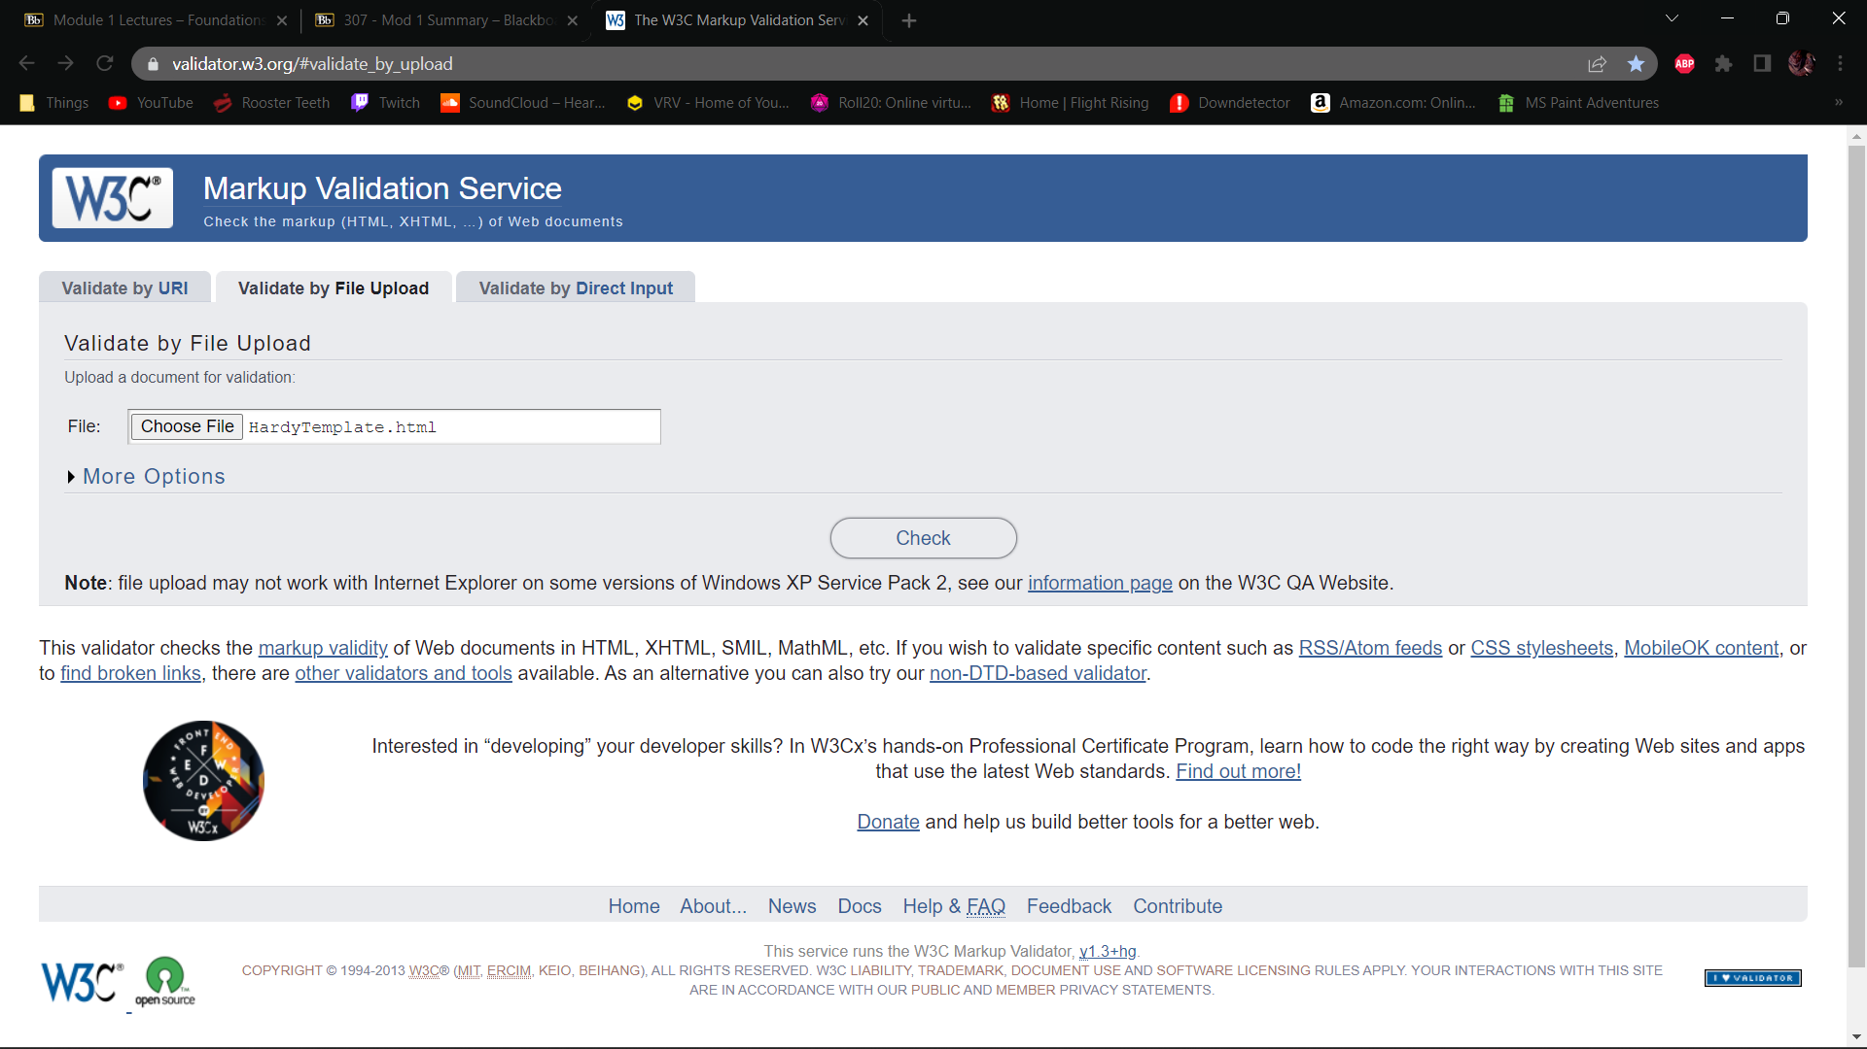

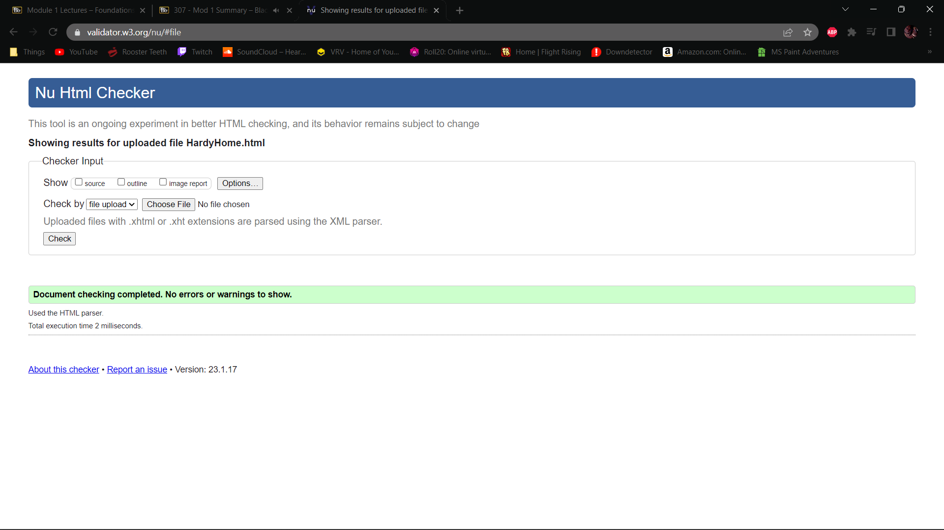

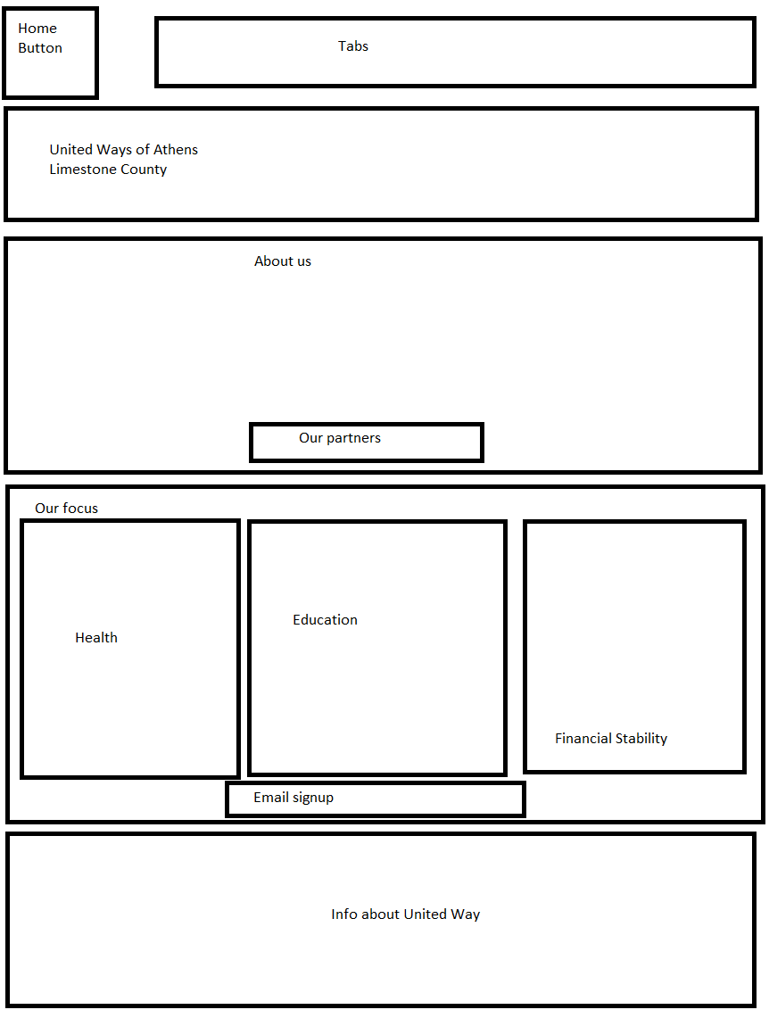

Athens Library

